A General Introduction to Dramatic Literature

Organized and Curated
By
Dr. Michael G. Rather, Jr.

NOTE
In some cases, excerpts from poems and critical works are included, for which the copyright is held by the poet or publisher. It is believed that the use of small portions of these works to illustrate concepts and educate qualifies as fair use under United States copyright law. If you are the copyright owner of a poem excerpted in this publication and wish to have it removed, contact me at mrather@lsco.edu.
Unless otherwise noted, this work is licensed under the Creative Commons Attribution-NonCommercial 4.0 International License.

Table of Contents
NOTE 1
Table of Contents 2
Basic Elements of Drama 3
Vocabulary and Concepts 5
Stage vs. Page 7
Vocabulary and Concepts 10
Tragedy 12
Vocabulary and Concepts 13
Ancient Comedy, Complications, and Modern Drama 14
Vocabulary and Concepts 16
Determining Theme 17

Basic Elements of Drama
A good place to begin the student’s study of Dramatic Literature is reflecting on the similarities between Dramatic Literature and other literatures. Everything the student has learned about reading fiction or poetry can be applied to the reading of Dramatic Literature. At some point in the student’s experience someone will hopefully have talked about the importance of context and connotation. Hopefully, at this point the student has a basic understanding of what is meant by allusions. If the student is studying Dramatic Literature at the same time as Poetry this semester, they will hopefully come to a basic understanding of the fundamentals of structuralism and formalism. They will have examined how language plays a part in poetry and how the examination of the poet’s choices with diction and syntax plays a role in our development of theme.
All of those elements are applicable to Dramatic Literature. Also important are the elements of fiction. Students will hopefully have encountered ideas such as: character, plot, setting, conflict, and theme before. All those ideas play a role in Dramatic Literature. Afterall, a play is usually a text that documents a narrative. Narratives document the growth of a character or characters in the face of a conflict. Plays do this as well. They can be written either in prose or verse.
Dramatic Literature is basically not radically different than anything the student has read before. All the concerns of fiction and poetry are concerns of Dramatic Literature. One concept that is shared by all literature is an attempt to express an individual’s experience. That is, Dramatic Literature artifacts, like other literature, is connected with the culture from which it is crafted. We can understand much about a culture from reading any literary artifact, but it could be argued that Dramatic Literature is uniquely suited to expressing the concerns of a culture.
The reason for this is that Dramatic Literature is written for performance. The student should not lose sight of this while reading plays as literary works. Plays have this interesting duality. They can be read as we read novels or poems, but they can also be performed in the same way that a film script or a song can be. As a document intended for performance, a play is consumed by an audience. All literature is consumed by an audience, but for the most part poems and novels and short stories are experienced individually whereas we go to the theater to experience a play. In the theater our experience of the performance is informed by those around us, and the experience is also informed by the interpretations of the actors, directors, and designers. The interpretation of a piece of Dramatic Literature is often a collaborative process.
There are structures of Dramatic Literature unique to the mode. For one, dialogue is emphasized in a script. There is little-to-no exposition usually in a script. What we learn about the setting and the events that transpired before the play comes from what our characters tell us. We do often learn a bit from what is sometimes called stage business. This information is given in stage directions and preface information. In those sections of the script we will be given names of players or characters, sometimes their ages, and sometimes a brief visual description. We might also get a short statement about time and place of the play. Sometimes, more exacting playwrights will give the reader a very thorough description of the setting, the space, and even the movements or blocking of the actors. This seems to be more common in plays written in the 20th and 21st century. Often directors and actors will use stage directions in the script to block where actors move during a scene. Sometimes those directions will also give the designers ideas for lighting, set design, and music.
But many scripts give almost no details about what the scene should look like or where the characters move at a certain moment in time. This information is interpreted by the director and the actors. Through a close reading of the play, these performers create living and breathing versions of the characters.
Approaching the reading of Dramatic Literature places the student very much in a role similar to that of a director or an actor. It calls upon the reader to think about how the script might be performed, how the script might be brought to life for an audience. That is a unique approach. Readers often do not know how to do this. They do not know how to visualize what they are reading, but is exactly what the student must do when reading a script. They must visualize what they are reading. They must take into account and draw from everything they have read, seen, or experienced. It is a way of reading with the whole of the imagination that the student might have forgotten in the drive to read for a specific theme or thesis statement.
Following where this there is a link to a collection of Susan Glaspell plays on Project Gutenberg. The play in the collection we recommend that the student read is “Trifles.” There will be activities related to the reading of that play after the student has read it.

“Trifles” by Susan Glaspell

Vocabulary and Concepts
Context – The information that informs the reading and production of a script. This is all the information relating to audience, culture, time, and the playwright.
Connotation – Meaning derived from context.
Allusion – A reference to a historical event or another story or poem.
Structuralism – A type of literary criticism that explores the way a text is shaped and its linguistic structures.
Formalism – Writing and criticism that focuses on form.
Diction – The types of words we use.
Syntax – The order of words.
Character – An “actor” in a narrative.
Plot – The events of a narrative.
Setting – The time and place where an event takes place.
Conflict – The tension between opposing desires.
Theme – What we learn about life from a work of art.
Play – Another word for a script of Dramatic Literature.
Narrative – A story.
Prose – Unmetered language. Language written without a concern of having a set rhythm.
Verse – Language that is metered. Language written with a rhythm in mind.
Audience – The people who are viewing a play or reading a poem or prose narrative.
Theatre – The space where a play is performed.
Actor – A person who adopts the personality and mannerisms of a character in a narrative.
Director – A person who attempts to control the various participants in producing a play. Often this person has a singular vision for the theme of a script and will attempt to see that vision become reality.
Designer – Contemporary theater production have a number of designers who work to create sets, lighting effects, sound effects, and costuming.
Dialogue- The words spoken by characters
Script – Another name for a play. The actual text of the play.
Exposition – The background information provided by an author.
Stage Business – The information the author or playwright provides concerning how actors should move across the space, lighting effects, sound effects, set design, etc…
Blocking – The movement of the actors across the stage.
Players – Another term for the actors or characters in a play.
Playwright – A writer of scripts.

Stage vs. Page
We have already talked about how scripts can be read in the same way we read poems and fiction, and we discussed that they also can be read for performance. This section of the text examines how these two ways of reading differ. Before emphasizing their difference, it is important to yet again point out their similarities.
Approaching a script as a piece of fiction or a traditional text and approaching it as a document meant to be performed both require reading for:

- Plot,
- Character,
- Setting,
- Theme,
- Use of Language,
- Use of Symbol,
- Use of Image,
- Figurative Language,
- Allusions,
- The Culture that Created the Script,
- The Author’s Interests, Ideas, and Writings on the Script.

But we add another level to the reading of a script. We need to think about how the script should be brought to life in a particular space. A theater can be any empty space. Plays have been performed in large formal spaces designed for travelling Broadway shows and on street corners. The script may be written to be performed in a particular space, or a director may select a script that was never intended to be performed in a space and adapt it to that space.
The reader can imagine the play in either way. It might be interesting to think about how the play would be performed outside if it has always been performed on a traditional stage. A good starting place to illustrate the importance of the performance space is discussing Ancient Greek theater.
Ancient Greek theater is one of the oldest forms of Dramatic Literature we have. Most of the scripts that exist still were written as part of a competition during a religious festival known as The Greater Dionysia. The plays (both comedies and tragedies) were then written as part of the worship of the Greek deity Dionysus. This important element plays a part in thinking about how the plays were performed. The space in which the playwright conceived of these plays was called orchestra. This semi-circular space was not where a band played or the audience sat. It was literally the arched space in front of what came to be called the skene. The skene was the tent or space from which the actor and the chorus come out to perform the play. The audience would surround the space. That space was referred to as the theatron and it is from that word that we have our contemporary word theater. This is important to remember. It is the existence of the audience that defines theatrical work for many people.
This unique space creates a number of effects for the performance. The space was outside. The plays limited by the light of the day and were tied to the times of the day. The space also limited the sort of scenes or settings that the audience could experience. Much of the world of the play had to be described through the chorus’s chant or the actors’ dialogue. These plays often include exposition then as part of the script, but unlike a novel the exposition is explained directly to the audience during the action of the play.
Exposition and scene description embedded in dialogue also plays a part in medieval and renaissance European plays. We are most familiar with Shakespeare’s works. Shakespeare’s plays were performed in an open theater as well known as the Globe. An image of the Globe is below:
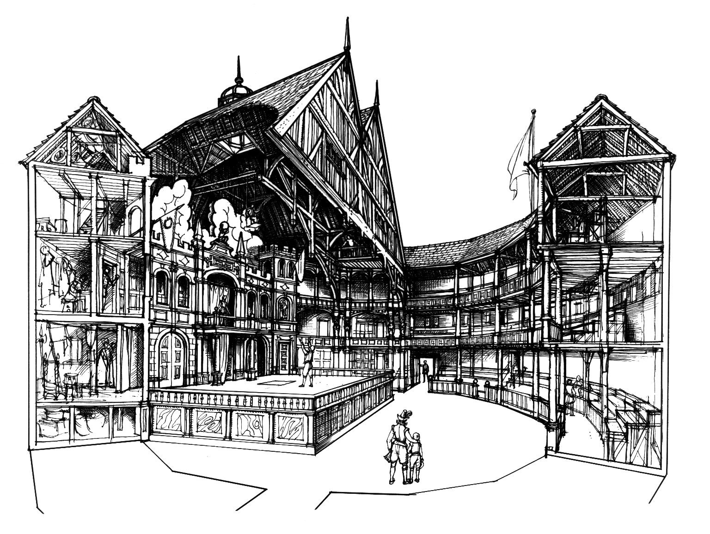
Fig. 1. Walter Hodges. Cut-away view of the Globe. Drawing. Folger Shakespeare Library. Web. 28 November 2019. Web. https://www.folger.edu/shakespeare-the-player-illustrating-elizabethan-theater-through-midsummer-nights-dream

It is easy to visualize how the plays would be performed at the Globe. We can see that, for the most part, they too would have been tied to daylight. Settings would have to be imagined. The audience would experience the play from different levels. In fact, groundlings were expected to be part of the action in many ways. If the play was not performed well, they would heckle the actors and even throw produce. The wealthier patrons would sit in the higher levels. Many of Shakespeare’s plays include great soliloquies. These speeches were directed to the audience by different characters in the plays. This theatrical convention was specifically a result of the sort of space the play is being performed in.
As theatre developed into more of what we think of it now, different spaces were used. The most commonly used is the proscenium stage. An image of this sort of stage appears below.

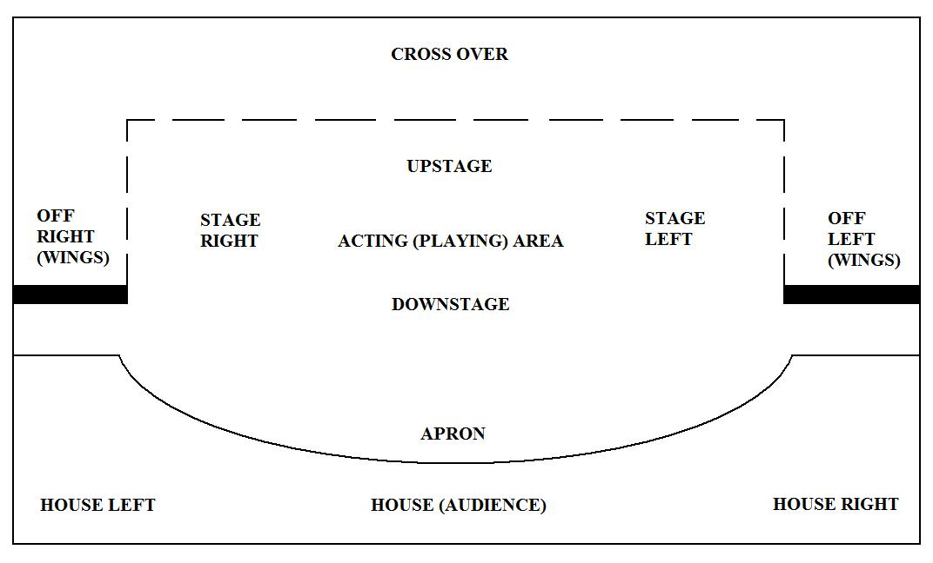
Fig. 2. Stage Layout Plan. Wikipedia. 28 November 2019. https://upload.wikimedia.org/wikipedia/commons/f/fa/Stage_Layout_Plan.jpg

This stage was based loosely on what came before, but now the play was performed inside and with the advent of electricity lighting effects could be integrated into the production. Sound effects always played a part, but when recording instruments developed, sound become a major component of productions. Actors had space with this sort of stage to change costume more frequently. In the medieval, renaissance, and ancient theaters, there were often stock characters or character types that a performer always played. Actors in the space pictured in Fig. 2 could play multiple characters in one performance. The audience becomes separated from the action with this sort of space. This is where we get the concept of the fourth wall. This separation between audience and performers created the sense that audiences were voyeurs. The audience was not expected to participate in the action. Over time, this convention began to be broken down again, but for the most part we still experience plays as happening separate from us.
In contemporary theater plays are performed in all sorts of spaces. Box theaters, street corners, open fields, reproduction spaces meant to bring back to life ancient stages and even the Globe are all used as performance spaces. Many high school students might have had or experienced a gymnasium that included a stage or a cafeteria that suddenly became a theater for the senior production.
It is important to keep in mind that the space in which the playwright imagines the play unfolding influences much of what we read in the script and even what characters say in the play. It is also important to remember that the plays are never limited to being produced in a single type of space. Shakespeare can be performed in an open field, or on a proscenium stage. One skill the student can develop while reading a script is to imagine the space it is being performed in. As the student reads the script, they might imagine themselves one of the designers for their own production. What might the set look like? How might they imagine the lighting? From which wing of the space do the actors enter and exit. What sort of soundtrack would the student create for the play? How does performing an Elizabethan script on a proscenium stage present challenges? These are fun things to consider while reading plays. It is also an experience not readily available to us when reading prose narratives and poems.
Linked below is the play is the play “Everyman.” We do not know for sure who wrote this play originally. It is an example of a Miracle Play. These were popular plays in the middle ages that taught morals with a mix of comedy. The plays are highly allegorical. Read the play and imagine the different ways it could be performed and the different spaces it could be performed in.

“Everyman” by Annonymous

Vocabulary and Concepts
Dionysus – Ancient Greek god who is connected to the harvesting of grapes and their fermentation into wine. Sometimes thought of as the “God of Wine,” but a much more complex figure than this. He is the only one of the Olympian deities to be born of a human woman. He is twice born haven been saved from his mother’s womb by his father Zeus and then sown into Zeus’s thigh to continue developing until he could be born. He is also said to be torn apart by his followers and resurrected afterward.

Orchestra – In Ancient Greek theaters this was the space upon which the actors performed.

Skene – We get the word “scene” from this Greek term. This was the tent or building at the back of the orchestra which housed the masks and costumes of the performers in Ancient Greek theatres. The actors and chorus would enter the stage and exit the stage from the skene.

Theatron – The area where spectators sat during a performance of Ancient Greek theatre.

Exposition – A portion of a narrative that provides background information about the characters, the setting, and the events that occur outside the scope of the narrative but influence the plot of the narrative.

Stock Characters – Characters that are instantly recognizable or genre specific.

Soliloquy – A monologue directed at the audience by a character. Often treated as though it is internal dialogue being spoken aloud.

Elizabethan – Any art, theatrical work, costuming, or writing produced during the reign of Elizabeth I of England. This is considered by many to be the height of the English Renaissance, and arguably a period where some of the finest English language literature was produced. Shakespeare’s works were primarily produced during this period.

Box Theater – A theater that can be configured in many different ways that is basically just a room. The seating can be moved. The set pieces can be moved. Audiences often surround the play as it is being performed.

Proscenium Stage – What we think of when we think of a theater. This is a space with a stage that thrusts out beyond a curtain and where audience are separated from the play as though a fourth invisible wall is present.

Groundlings – In Elizabethan theater and Renaissance theater in England these theater patrons were often of the lower economic classes and would stand immediately in front of the stage. They would often interact with the actors as the play unfolded.

Fourth Wall – The imaginary wall between the action of the play and the audience.

Voyeurs – People who watch events unfold without actually participating in those events.

Tragedy
In theater we often divide plays into two large categories: tragedy and comedy. The basic connotations of these two genres is what one might expect. Tragedies often deal with the failure of a play’s protagonist and comedies often explore silly behavior or actions of the characters. Comedies make us laugh, and tragedies make us contemplate our mortality. But both genres can have more complex connotations in the readings of Dramatic Literature. In this section, the focus will be on Tragedy.
When we hear the word “tragedy” we want to assume that the play is “sad.” That is often the case. We know that the difference between a tragedy and a comedy is that tragedies involve a failure on the part of the protagonist or the character who we hope will succeed in the narrative. Failures can be saddening, but they also can be education. Tragedies often have societal message intertwined in their plot. Tragedies are an attempt to teach an audience about some concept the playwright wants to get across.
Like most things with western theater, we can trace the origin of tragedy to Ancient Greece. We already discussed the festival nature of the plays produced in Ancient Greece. These plays were produced as a part of a festival for Dionysus who was said to be torn apart by his followers every year and then resurrected in the spring of the year. The festival’s plays were part of a competition and three “poets’ were to produce these plays for the audience who was expecting to experience katharsis.
Katharsis is an attempt to invoke pity and fear in the audience. It comes from experiencing the events of the plot unfold and being aware of the mistakes that the protagonist is making throughout the unfolding of the plot. Through this experience, the audience is said to be “purged” of their fear. This fear is tied to the notion of fate which to many ancient Greeks was something beyond their control but also known to the gods. Understanding the religious perspective of ancient Greeks helps the reader understand how these plays are constructed.
The ancient Greek tragedies followed a tragic hero. This hero is shaped by a singular strength called their hamartia. The hamartia is also the protagonist’s weakness. The hero experiences a reversal of fortune because of their hamartia. This reversal is usually a change of status in some way. The hero moves from nobility or noble station to a lower station as a result of hamartia.
Perhaps the most famous of the ancient Greek tragedies is Oedipus Tyrannos by Sophocles. Oedipus is a member of the royal house of the Greek city state Thebes, but he is not aware of his familial connections to the house. He was raised in the Greek city state of Corinth. Before the play begins, he has traveled to the Delphic oracle to discover his future (as many Greek mythological heroes do). There he is told that he will kill his father and marry his mother. In order to avoid this fate, he leaves Corinth to seek his fortune elsewhere. Along the way he comes to a crossroads at the same time as a noble man he does not recognize. The noble man refuses to make room for Oedipus, and because of this they come to blows. In the ensuing battle, Oedipus kills the noble man. He continues down the road to Thebes and discovers the city state under the threat of the sphinx. The sphinx is a mythological beast that is part woman, part lion, and part eagle. The monstrosity would not let anyone in or out of the city unless they could answer its riddle. The riddle was, “What walks on four legs in the morning, two legs in the afternoon, and three legs in the evening.” Oedipus successfully answered the riddle. The sphinx threw itself from the walls in despair and dies. Oedipus is heralded as a hero and savior of Thebes. He is offered the position of king since their King Laius has disappeared. He is also offered the hand of the previous queen, Jocasta, which he takes excitedly. They are married. He has four children with her. Sophocles’s play, Oedipus Tyrannos, picks up years later when Thebes is under a plague. The citizens are praying to the gods and Oedipus to solve the plague and he has sent Jocasta’s brother, Creon, to the Delphic oracle to find out what they must do.
A translation of the play is linked below.

“Oedipus Tyrannos” by Sophocles and translated by F. Starr

As the student reads this play, it is a good idea to think about what Oedipus’s hamartia is. What is at the root of his failure? Think about what causes that failure and whether he is a victim of fate or if he creates his own tragedy.

Vocabulary and Concepts
Tragedy – A play in which the protagonist fails in their goals.

Protagonist – The character in a play who we support. The character we hope succeeds.

Katharsis – The purging of negative emotions from the audience while watching a tragedy.

Fate – In ancient Greece, fate was thought of as a goddess with three manifestations. Their names were Clotho, Atropos, Lachesis. One would make the thread of a person’s life, one would measure the thread, and one cut the thread of the person’s life when it was their time to die.

Tragic Hero – A hero who is the primary protagonist of a play. This hero is fated to fail. They have a strength that is also their weakness, must be of noble status, and must experience a reversal of fortune.

Hamartia – A flaw in the protagonist of a tragedy that can also be consider the character’s strength.

Antagonist – Force or character that works against the protagonist.

Ancient Comedy, Complications, and Modern Drama
Comedy is a strange concept in the theater. When people unfamiliar with literary history think of comedy, television shows like sitcoms come to mind or funny movies. Sometimes these films or shows are quite vulgar. There are examples of ancient Greek comedies that by today’s standards would be vulgar. Scripts like Lysistrata by Aristophanes where Athenian women refuse to have sec with Athenian men until they end the war are examples of this sort of humor, but in its most strict definition a comedy is simply a play with a happy ending. It was some time before theater evolved into the multiple genres we know today.
Opposed to comedies in contemporary theater are Dramas. We rarely think of these plays as out right tragedies. Many dramas will also have a comedic element. Many dramas will not necessarily end on a tragic note, but they don’t necessarily end with everything “hunky dory” as the traditional concept of a comedy would have it. Many dramas deal with average people. This is one way they differ from the ancient tragedies. Ancient tragedies, according to Aristotle, required that the tragic hero be of noble stature. There is no requirement like that in contemporary drama.
As European theater developed from the classical theatre of Greece and Rome and evolved through the medieval period into the Renaissance into what we know of it now, it reacted to different historical pressures and technologies. We already examined Everyman which is an example of a salvation play. In the Renaissance other genres also developed like Comedia Dell’ Arte. Comedia Dell’Arte troupes focused on ensemble acting and drew inspiration from comedic takes of recognizable literary stories. Stock Characters existed in these troupes. The most popular and recognized into modern literature is the character of the Harlequin. Elements of Comedia Dell’Arte appear in modern theater such as the ensemble structure of sketch comedy shows and improvisation troupes.
Certain tropes from Comedia Dell’Arte influenced the works of Shakespeare and Ben Johnson, two of the most famous figures of British literature. Below is a link to one of Shakespeare’s most famous plays A Midsummer Night’s Dream.

"A Midsummer Night's Dream" by William Shakespeare

While reading the play it is important to think about certain conventions and stock characters in it still exist in contemporary film and television. Shakespeare borrowed liberally from older stories and mythologies as do contemporary playwrights and screenwriters.
Comedy and Drama become more complex through the nineteenth century and into the twentieth century. Often, in contemporary theater and film it is difficult to separate the two. In the mid-twentieth century distinct genres of theatre developed that attempted to challenge theatrical conventions. The Theater of the Absurd and Theater of Cruelty are two well-studied types. From them came ideas such as tragicomedy. Perhaps one of the most famous playwrights of this type of theater, Samuel Beckett, created plays that challenged the forward movement of plot, ideas about character development, and even what a theatrical scene might be. His height of popularity was post-World War II, and we can think of the advent of these complicated types of theater as a reaction to the economic, cultural, and societal upheaval caused by the two world wars. But precursors to Beckett exist. One famous play is Six Characters in Search of an Author by Luigi Pirandello. The play blurs the lines of comedy and drama. It challenges the fourth wall divisions between audience and actors, actors and characters, playwright and director. Modern theater is a story of challenging conventions and pushing the boundaries of what can be imagined on stage. Below is a link to Pirandello’s play.

"Six Characters in Search of an Author" by Luigi Pirandello

As the student reads the text, again it is useful to think of how the play is similar to what they have read before, and how it differs. It is interesting to try to think about how this play fits the conventions of comedy and the conventions of drama.
Dramatic literature is uniquely positioned as a genre to speak to groups of people about notions of national identity, political identity, and cultural identity. Playwrights, like all artists, have used the genre’s nature to advance political and cultural philosophies. It can be argued that this also is one reason why dramatic literature has often been the last of the literary genres to be freed from censorship. The social nature of a play leads inevitably to audience conversation about the content of plays. This is why so many plays feel charged with political and social criticism. This adds to the complications of simply categorizing a play as comedy or drama. Read Anton Chekhov’s “The Cherry Orchard” for an example.

“The Cherry Orchard” by Anton Chekhov

Are there elements of the play that are funny? Could a director approach this as a comedy or a tragedy? Could it develop into both? What about “Riders to the Sea” by J.M. Synge?

“Riders to the Sea” by J.M. Synge

What does this play tell us about Irish culture? How does it teach us about the concerns of a particular people who are oppressed at a particular time?
As dramatic literature moves deeper into the twentieth century the plays become more diverse, more audience directed (designed for specific audiences), and more didactic. Many of the greatest plays of the twentieth century challenge the audience in ways that are quite uncomfortable. Death of a Salesman by Arthur Miller, Fences by August Wilson, Angels in America by Tony Kushner, and even into the twenty-first century plays like the current (as of 2019) play Slave Play by Jeremy O’Harris are challenging our ideas and assumptions about the various theatrical genres and what can be down on stage. Any of the previously mentioned works of dramatic literature would reward the student reader.

Vocabulary and Concepts
Comedy – A play with a happy ending.

Genre – A category in which we divide and classify types of literature or art.

Drama – A type of theatrical work that is often serious.

Salvation Play – A play that illustrated what men must do to earn salvation in the Judeo-Christian tradition.

Comedia Dell’Arte – A form of theater characterized by masked types. Often humorous and improvisational with characters who perform specific roles and parody traditional literary works.

Stock Characters – Instantly recognizable characters who behave in culturally expected ways.

Theatre of the Absurd – A form of theater beginning after World War I and continuing well into the second half of the twentieth century that sought to upend theatrical conventions by creating plays that ignored dynamic characters, ignored traditional plot, and focused on linguistic play and in many was an existential philosophy.

Theatre of Cruelty – A form of theater that tries to “liberate the senses” by focusing on primal elements of sound and sight.

Tragicomedy – Blending of both the comic and tragic forms of dramatic literature.

Determining Theme
Determining theme with dramatic literature is not overly different from determining theme in other arts. We have already discussed how we can use many of the same skills reviewed in the analysis of poetry. Dramatic literature can be written in verse just like a sonnet. In fact, most of Shakespeare’s work is written in blank verse which is unrhymed iambic pentameter. Many translations of the ancient Greek tragic playwrights are also written in verse. All the skills used to analyze a poetic work are applicable to dramatic literature. It is useful to remember that theater as a literary form mean to be performed uses sound in much the same way that poets do.
Beyond the application of linguistic elements of sonic and visual construction, contextual elements play a major role in our interpretations of a play’s theme. One element that is somewhat lost with approaching dramatic literature and reading it in the same way that on reads a novel is the effect of experiencing the script with an audience. The communal experience is central to the experience of theatrical work. If given the opportunity to experience the play with an audience or read it with a group, take it. Many of the lays listed here or that the teacher of this course will mention have film versions. Try to get with class mates or friends and experience the play through their eyes. Have discussions about how the play connects to contemporary culture and contemporary issues. Dramatic literature also represents the importance of constantly reinterpreting a literary work.
Often we believe that a literary work has one way of being read, or one way of being experienced, or one “right answer” for its theme. That is not true. It is one of the main ways students are misled in approaching literature. Plays prove the falseness of the singular interpretation of a piece of art because of their interpretative nature. If Shakespeare’s plays only had one theme and one way to be produced, would we still be producing his work nearly 500 years later? If the types in a Comedia Dell’Arte troupe only could be interpreted one way, would they have evolved into famous comic book super heroes and villains? Would the ensemble improvisational theatrical troupes have evolved? Would we have shows like Saturday Night Live?
The teacher of this course will most likely have their own ideas about the themes of a script and what is important in a play. Don’t let their interpretations deter you from your own. Just remember, any interpretation that a student develops must be rooted in the script itself and then move out from there. When the student interprets the theme of a play, they need to begin with what is on the page and then apply their understanding of how the characters and conflicts and scenes speak to a contemporary audience. The student can see themselves as a director or an actor who can bring the words on the page to life for an audience.

