Module 8 Genderization
Chapter 12. Gender, Sex, and Sexuality
Assignment Quiz 10 points
1. The terms “masculine” and “feminine” refer to a person’s. 1 point
2. _______ is/are an individual’s self-conception of being male or female based on his or her association with masculine or feminine gender roles. 1 point
3. Research indicates that individuals are aware of their sexual orientation ___________________. 1 point
4. A person who is biologically female but identifies with the male gender and has undergone surgery to alter her body is considered 1 point
5. Why do sociologists find it important to differentiate between sex and gender? What importance does the differentiation have in modern society? 3 points
6. Consider the types of derogatory labelling that sociologists study and explain how these might apply to discrimination on the basis of sexual orientation. 3 points
This Page contains links to resources on gender roles in advertising. After reviewing this material, click Next to view the next Page.
Sexism in Advertising
Video: Women Review Sexist Vintage Ads
Video: Top 10 Most Sexist Commercials of All Time!
Media's Effects on Genderization and Exploitation
Miss Representation: 'You Can't Be What You Can't See' - 3% Conference
Sexual Stereotypes in the Media
Assignment 15 points
Find an advertisement which utilizes genderization and/or exploitation. Post the advertisement as an image (you may need to save the image first) and explain your reasons for picking that specific advertisement. Then respond to a classmates post including your opinions on their advertisement. You will not be able to see fellow classmates posts until your have posted your initial response.
LGBTQ
This Page contains links to additional resources available through the Fletcher Library and Open Access sources. After reviewing this material, click Next to see your response assignment.
Encyclopedia page: Gay, lesbian, and Queer Cinema
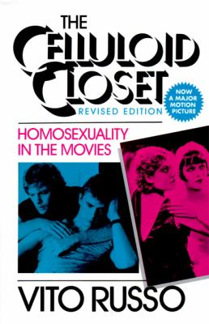
(Book available in Fletcher Library, Schriever location: PN1995.9.H55 R8 1987)
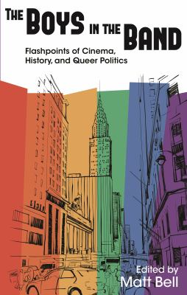
(Open Access eBook available through Fletcher Library via Project Muse)
Assignment The Celluloid Closet 10 points
Watch the documentary titled The Celluloid Closet (Available through Amazon Instant Streaming for $3.99).
Choose one of the following questions and write a 300+ word response in a body paragraph(s) that includes a Topic Sentence, examples, and a concluding sentence.
- Discuss the evolving portrayal of homosexuality in the movies. Specifically, focus on character types such as the sissy. May also want to discuss how ideas of femininity and effeminacy influenced and are depicted in films referenced in the documentary.
- What social/political/religious factors influenced the censorship of homosexuality in films? Give some examples of changes that occurred as a result of new motion picture codes. How did this influence how homosexuals were portrayed in films? You may also want to discuss how screenwriters and directors got around the Hays Code? Give some specific examples.

